Medicine Wheel Recovery Services, Inc.
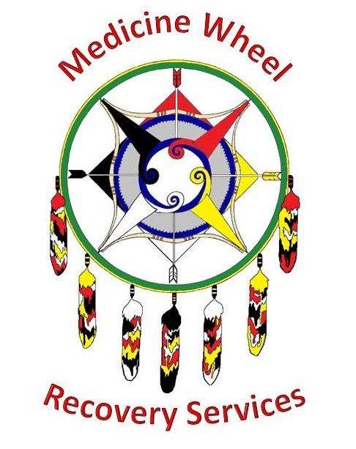
58147 Columbia River Highway, Suite C; St. Helens, Oregon 97051
Phone: (503) 396-5322; Fax: (503) 410-5678
www.medicinewheelrecoveryservices.org
DUII Educational Courses
MODULE 5: SUBSTANCE USE DISORDER RECOVERY SUPPORT SERVICES
- Complete the “Give Yourself a Hand” worksheet
AFTER COMPLETING PAPERWORK
- Name one thing you have learned:

- Name one thing you want to learn more about:

